TURBO

**Extro Curve Spout Wall Mixer** – Twin Knob Design  
**Product Description:** Stylish wall-mounted mixer with a central curved spout and dual control knobs, ideal for kitchens and wash areas that require both hot and cold water mixing.  
 **Key Features :**

✅ Dual knob control for hot and cold mixing

✅ Elegant high-arc central spout

✅ Durable chrome-plated brass body

✅ Wall-mounted design for space-saving

✅ Smooth flow with anti-splash aerator  
**Product Specifications:**  
• Brand: Extro  
• Product Type: Wall Mixer with Curve Spout  
• Material: Brass  
• Finish: Chrome-plated  
• Handle Type: Round twin knobs  
• Mount Type: Wall mounted  
• Installation: Standard wall installation  
• Usage: Suitable for kitchens and washbasins  
• Warranty: 5 years

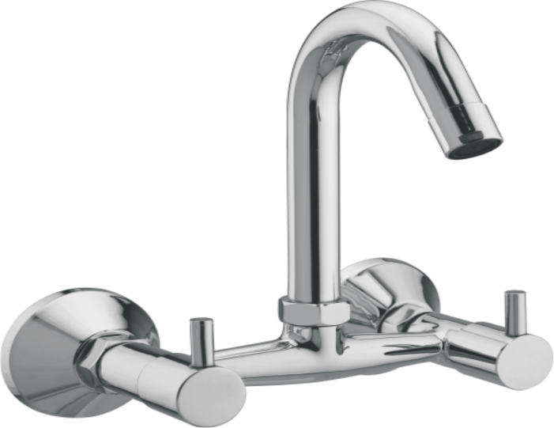

**Extro Concealed Stop Cock** – Round Handle  
**Product Description:** A sleek and compact concealed stop cock designed for precise water flow control, ideal for modern bathrooms and kitchens.  
**Key Features :**

✅ Concealed fitting for a clean look

✅ Rust-resistant brass body

✅ Easy quarter-turn operation

✅ Durable chrome finish

✅ Suitable for both hot and cold water  
**Product Specifications:**  
• Brand: Extro  
• Product Type: Concealed Stop Cock  
• Material: Brass body with chrome finish  
• Handle Type: Single round lever  
• Mount Type: Concealed wall mounting  
• Connection Size: Standard 15mm inlet/outlet  
• Finish: Polished chrome  
• Application: Suitable for bathrooms, kitchens, and utility areas  
• Warranty: 10 years

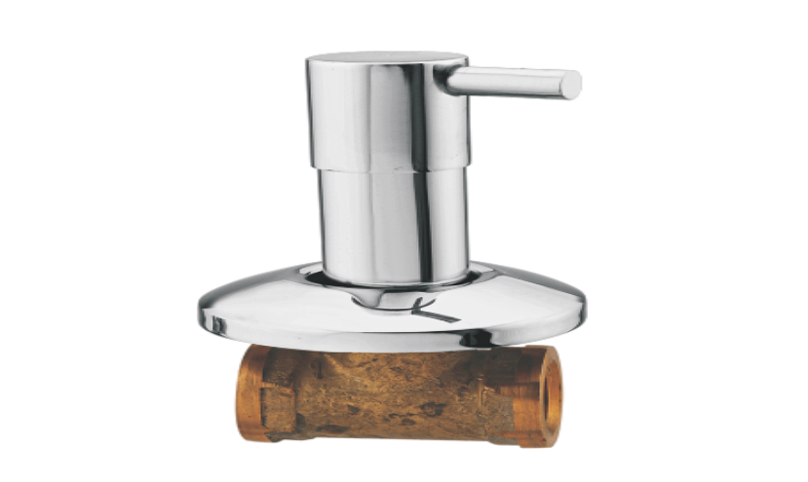

**Extro Concealed Stop Cock** – Long Body  
**Product Description:** Stylish concealed stop cock with a longer body for enhanced reach and control, ensuring smooth water flow regulation in concealed plumbing systems.

**Key Features :**

✅ Long body for easy accessibility

✅ Corrosion-resistant brass internals

✅ Sleek chrome-plated finish

✅ Smooth quarter-turn mechanism

✅ Ideal for hot and cold water supply

**Product Specifications:**  
• Brand: Extro  
• Product Type: Concealed Stop Cock (Long Body)  
• Material: Forged brass with high-polish chrome coating  
• Handle Type: Round control lever  
• Mount Type: Concealed wall-mounted  
• Connection Size: 15mm BSP inlet/outlet

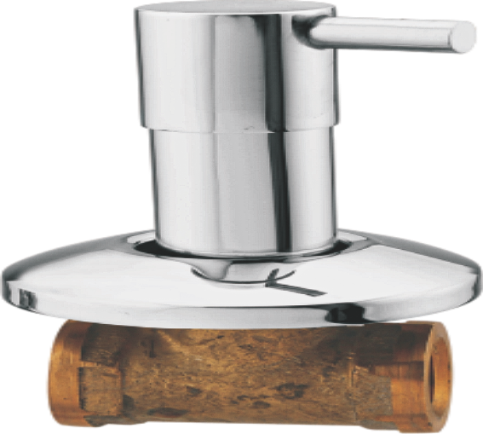

**Extro Bib Cock** – Round Handle  
**Product Description:** Wall-mounted bib cock with a sleek round handle, crafted for durability and smooth water control, ideal for kitchen and bathroom installations.  
**Key Features :**

✅ Smooth quarter-turn operation

✅ Rust and corrosion-resistant body

✅ Elegant round knob design

✅ Easy wall mounting

✅ Water-saving aerator

**Product Specifications:**  
• Brand: Extro  
• Product Type: Bib Cock  
• Material: Brass with chrome plating  
• Handle Type: Round lever  
• Mount Type: Wall-mounted  
• Inlet Connection: 15mm BSP  
• Finish: Glossy chrome  
• Flow Type: Single flow  
• Application: Suitable for bathroom, kitchen, utility areas  
• Warranty: 10 years

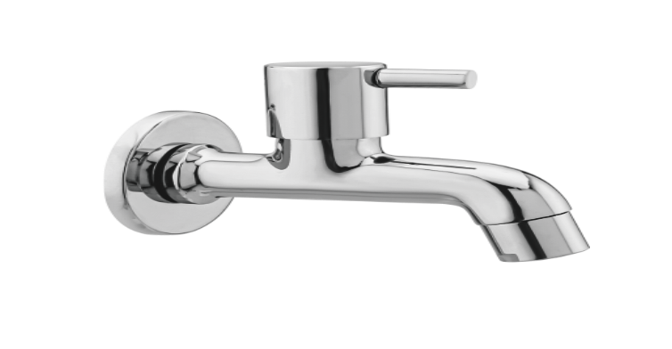

**Extro Long Body Bib Cock** – Round Handle  
**Product Description:** Extended spout bib cock with round lever handle, offering smooth water flow and modern aesthetics for kitchen or utility use.  
**Key Features :**

✅ Long body for extended reach

✅ Sleek and compact round handle

✅ Rust-resistant chrome finish

✅ Smooth quarter-turn mechanism

✅ Wall-mounted for space efficiency  
**Product Specifications:**  
• Brand: Extro  
• Product Type: Long Body Bib Cock  
• Material: Brass with chrome plating  
• Handle Type: Round lever  
• Mount Type: Wall-mounted  
• Inlet Connection: 15mm BSP  
• Finish: Glossy chrome  
• Flow Type: Single flow  
• Application: Suitable for kitchen sink, bathroom basin, utility  
• Warranty: 10 years

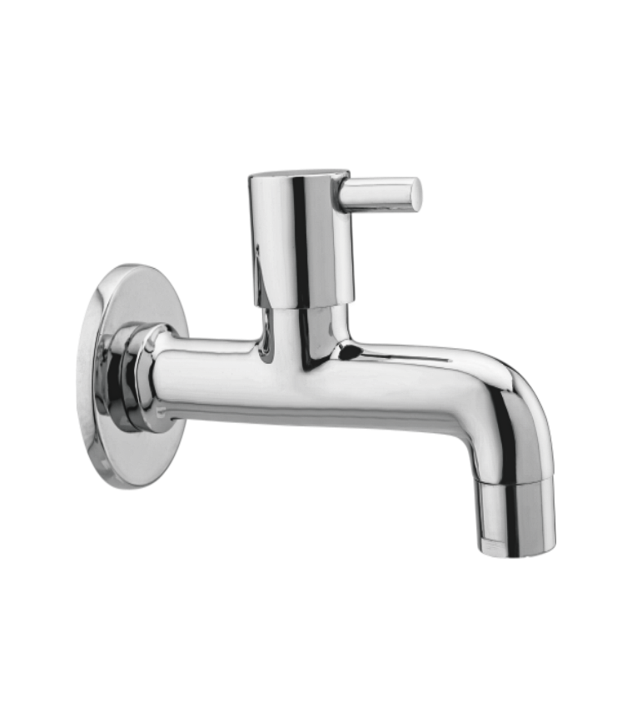

**Extro Angular Stop Cock with Flange** – Round Handle  
**Product Description:** Precision-engineered angular stop cock with modern round handle, ideal for geysers, flushing systems, and concealed connections.  
**Key Features :**

✅ Durable brass body with chrome finish

✅ Quarter-turn round handle

✅ Corrosion-resistant build

✅ Easy wall-mount installation

✅ Compatible with standard 15mm fittings  
**Product Specifications:**  
• Brand: Extro  
• Product Type: Angular Stop Cock  
• Material: Brass with chrome plating  
• Handle Type: Round knob  
• Mount Type: Wall-mounted with flange  
• Inlet Size: 15mm BSP  
• Outlet Type: Male thread for attachment  
• Finish: High-gloss chrome  
• Application: Geysers, flush tanks, basins  
• Warranty: 10 years

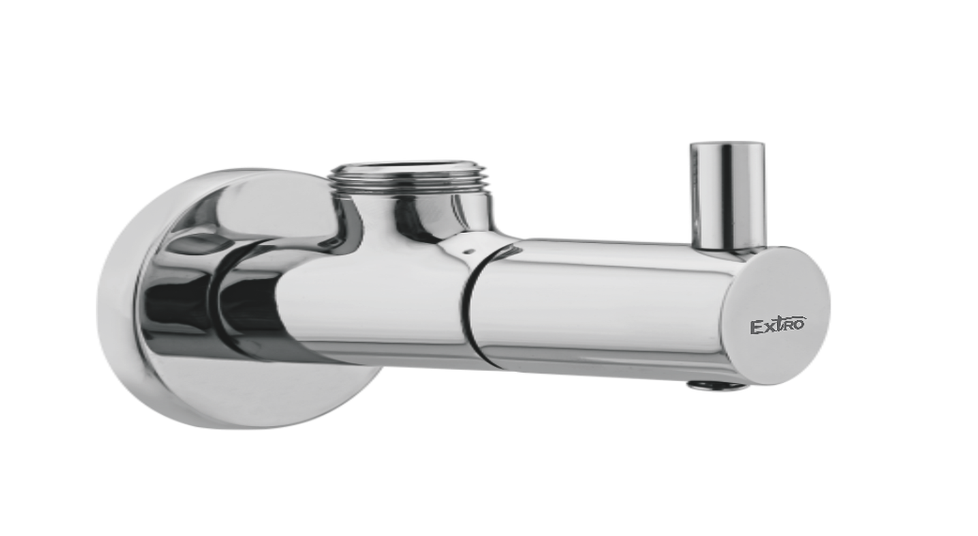

**Extro Pillar Cock** – Round Handle  
**Product Description:** Sleek and compact pillar cock with a modern round knob, perfect for countertop basins in residential and commercial spaces.  
**5 Key Features (in single line):**

✅ Stylish chrome-plated design

✅ Easy-to-use quarter-turn handle

✅ Solid brass construction

✅ Smooth water flow

✅ Ideal for wash basins and counters  
**Product Specifications:**  
• Brand: Extro  
• Product Type: Pillar Cock  
• Handle Type: Round knob  
• Material: Brass with chrome finish  
• Installation: Deck-mounted  
• Inlet Connection: 15mm BSP  
• Flow Type: Regular stream  
• Finish: Mirror-like chrome  
• Application: Basin / Countertop sink  
• Warranty: 10 years

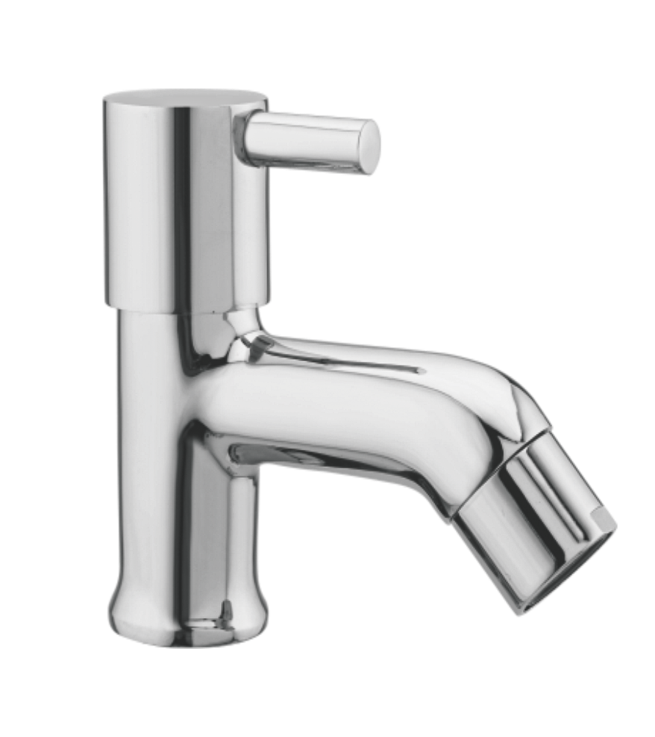

**Extro Two-Way Bib Cock with Round Handle**  
**Product Description:** Dual-purpose wall-mounted bib cock with a round knob handle and two outlets, suitable for both water tap and washing machine or jet spray connections.  
**Key Features :**

✅ Dual outlet for multipurpose use

✅ Premium chrome finish

✅ Smooth quarter-turn operation

✅ Durable brass body

✅ Includes wall flange for clean installation  
**Product Specifications:**  
• Brand: Extro  
• Product Type: Two-Way Bib Cock  
• Handle Type: Round knob  
• Material: Brass with chrome coating  
• Installation: Wall-mounted  
• Inlet Connection: 15mm BSP  
• Outlets: 2 (main flow and bottom connection)  
• Finish: Glossy chrome  
• Suitable For: Bathroom, washing machine, jet spray  
• Warranty: 10 years

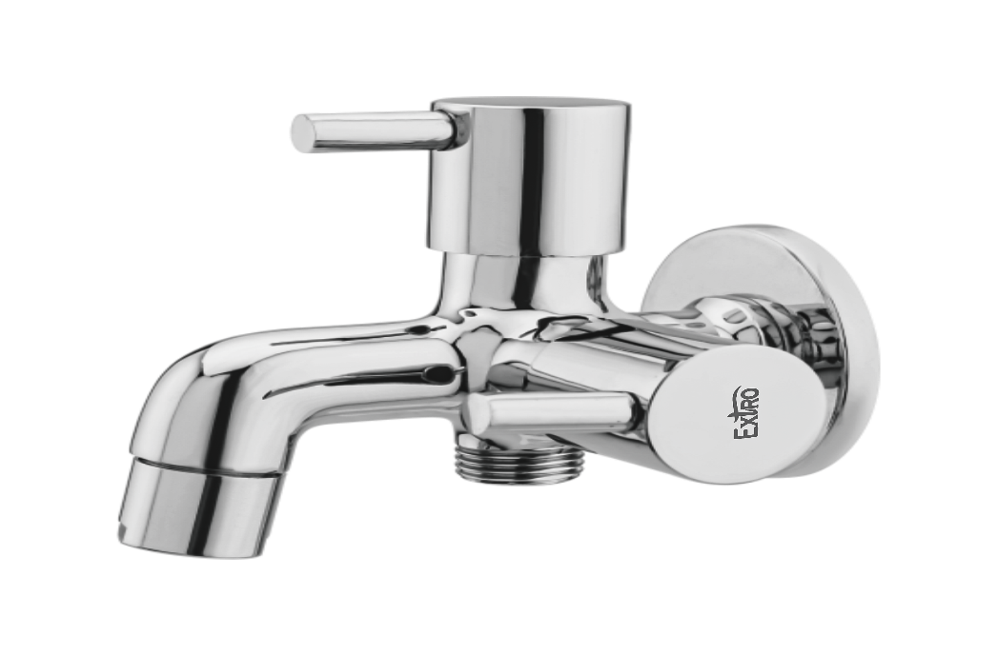

**Extro Two-Way Angle Cock with Dual Control Handle**  
**Product Description:** Premium two-way angle cock with dual outlets and individual control levers, designed for controlling two connections such as geyser and jet spray simultaneously.  
 **Key Features :**

✅ Dual outlet angle cock for multiple uses

✅ Individual lever controls for each outlet

✅ Chrome-plated brass for durability

✅ Wall-mounted with flange

✅ Rust-resistant and leak-proof design

**Product Specifications:**  
• Brand: Extro  
• Type: Two-Way Angle Cock  
• Material: Brass with chrome finish  
• Installation Type: Wall-mounted  
• Control: Dual handle lever mechanism  
• Inlet Connection: 15mm BSP  
• Outlets: 2 (side and bottom)  
• Finish: Mirror chrome  
• Suitable For: Bathrooms, geysers, jet sprays, washing machines  
• Warranty: 10 years manufacturer warranty

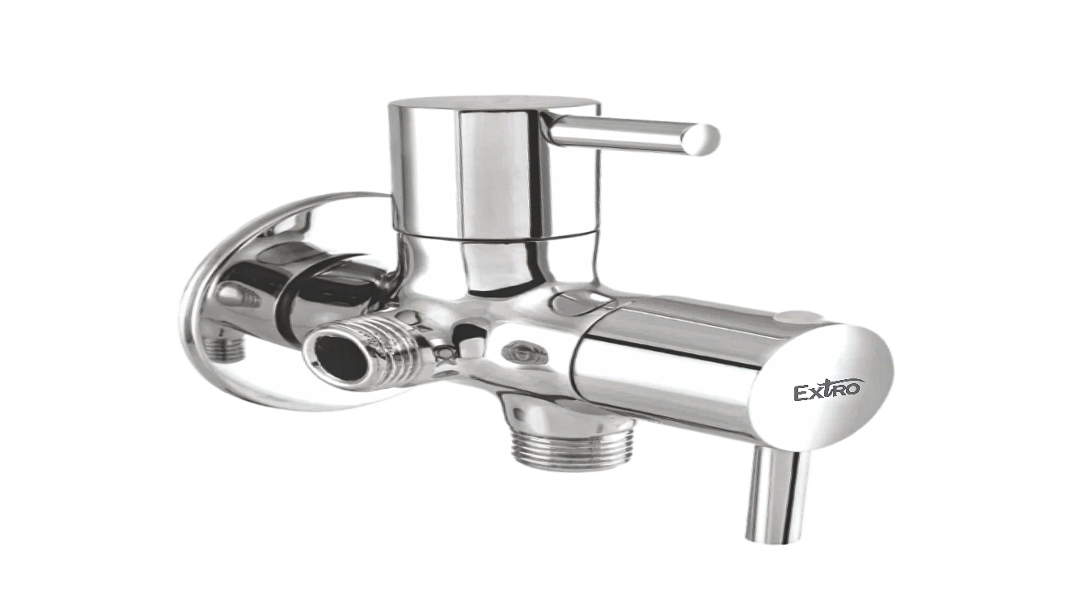

**Extro Swan Neck Tap – Wall Mounted**

**Product Description:** Stylish swan neck wall-mounted tap designed for easy water flow control and enhanced kitchen or bathroom aesthetics, made with durable brass and chrome finish.

**Key Features :**  
✅ Elegant swan neck spout design

✅ Smooth quarter-turn operation

✅ Chrome-plated brass body

✅ Wall-mounted for space-saving

✅ Rust and corrosion-resistant finish

**Product Specifications:**  
• Brand: Extro  
• Type: Swan Neck Wall Tap  
• Installation Type: Wall Mounted  
• Material: Brass  
• Finish: Mirror Chrome Plating  
• Handle Type: Single Lever (quarter-turn)  
• Inlet Connection: 15mm BSP  
• Spout: Fixed swan neck  
• Suitable For: Kitchen sinks, utility areas, wall-mounted basin supply  
• Warranty: 10 years manufacturer warranty

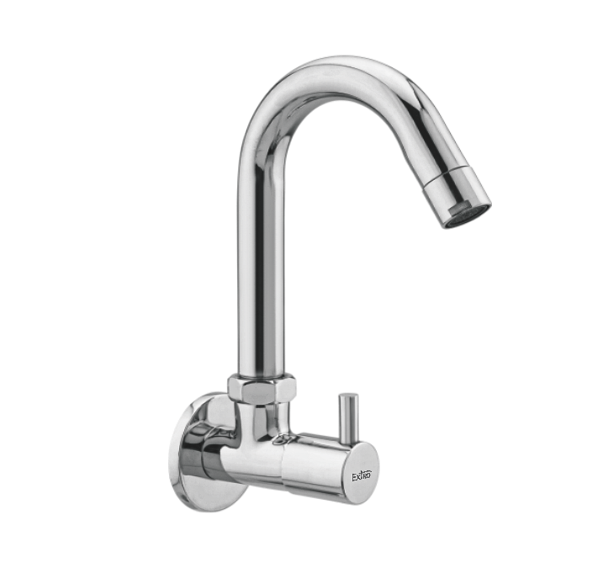

**Extro Swan Neck Tap – Table Mounted**

**Product Description:** Elegant and durable table-mounted swan neck tap with a smooth flow spout, designed for ease of use and modern aesthetics in kitchen or basin setups.

**Key Features :**  
✅ High curved swan neck design

✅ Rust-free chrome-plated brass body

✅ Easy quarter-turn lever

✅ Smooth water flow

✅ Table-mounted installation

**Product Specifications:**  
• Brand: Extro  
• Type: Swan Neck Table Tap  
• Installation Type: Table Mounted  
• Material: Brass  
• Finish: Mirror Chrome Plating  
• Handle Type: Single Lever (quarter-turn)  
• Spout Style: Fixed swan neck  
• Inlet Connection: 15mm BSP  
• Suitable For: Kitchen sinks, wash basins  
• Warranty: 10 years manufacturer warranty

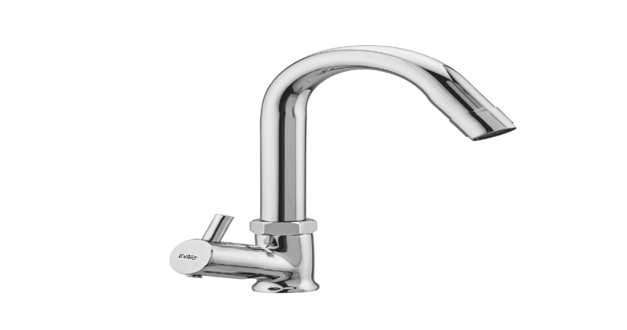

**Extro Swan Neck Dual Handle Sink Tap – Table Mounted**

**Product Description:** Stylish swan neck sink tap with dual lever handles for hot and cold water control, designed for tabletop installation in kitchen or utility areas.

**Key Features :**  
✅ Dual control levers for hot & cold water

✅ Smooth swan neck spout

✅ Chrome-plated brass for durability

✅ Table-mounted design

✅ Elegant, modern look

**Product Specifications:**  
• Brand: Extro  
• Type: Dual Handle Swan Neck Sink Tap  
• Installation Type: Table Mounted  
• Material: Brass  
• Finish: Mirror Chrome Plating  
• Handle Type: Dual Lever (quarter-turn)  
• Spout Style: Fixed swan neck  
• Inlet Connection: 15mm BSP x 2 (hot & cold)  
• Suitable For: Kitchen sinks, basin counters  
• Warranty: 10 years manufacturer warranty

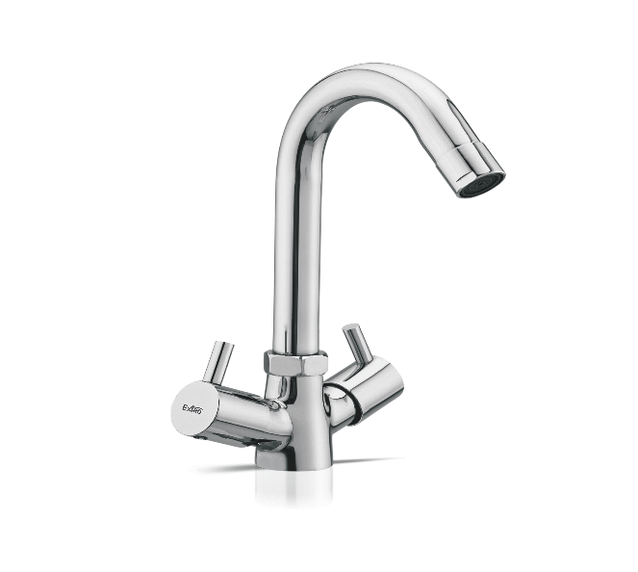

**Extro Wall Mixer with Overhead & Hand Shower Provision – 3-in-1**

**Product Description:**  
A versatile wall mixer faucet with dual levers for hot and cold water control, featuring a central diverter knob for switching between spout and overhead/hand shower output. Ideal for modern bathrooms.

**Key Features :**  
✅ 3-in-1 wall mixer with diverter

✅ Dual lever operation for temperature control

✅ Centralized knob for flow direction

✅ Chrome finish for elegant look

✅ Robust brass body construction

**Product Specifications:**  
• Brand: Extro  
• Model: Wall Mixer with Overhead Shower & Hand Shower Provision  
• Installation Type: Wall Mounted  
• Body Material: Brass  
• Finish: High-Gloss Chrome  
• Controls: Dual Levers (Hot/Cold), Center Diverter  
• Outlet Options: Spout, Overhead Shower, Hand Shower  
• Inlet Connection: 15mm BSP  
• Suitable For: Bathrooms with both shower & tub/spout  
• Warranty: 10 Years Manufacturer Warranty

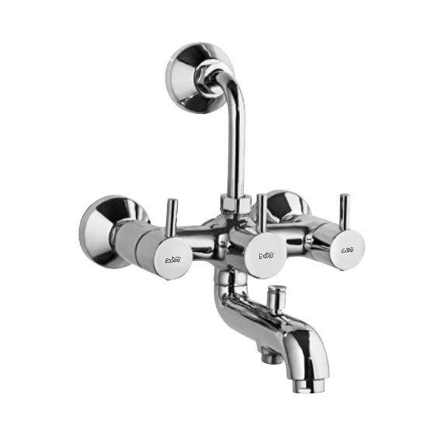

**Extro Wall Mixer with Bend Pipe for Overhead Shower**

**Product Description:**  
A sleek wall mixer faucet combining hot and cold water with an overhead shower connection via an extended bend pipe. Ideal for modern bathrooms requiring both tap and shower outputs.

**Key Features :**  
✅ 3-in-1 function with overhead shower option

✅ Dual knob control for hot & cold

✅ Extended bend pipe for easy shower access

✅ Sleek chrome-plated brass body

✅ Wall-mounted design for compact installations

**Product Specifications:**  
• Brand: Extro  
• Model: Wall Mixer with L-Bend Pipe  
• Installation Type: Wall Mounted  
• Material: Brass  
• Finish: Polished Chrome  
• Control Type: Dual Lever + Diverter  
• Water Flow Options: Spout and Overhead Shower  
• Inlet Connection: 15mm BSP  
• Usage: Bathroom Faucet with shower provision  
• Warranty: 10 Years Manufacturer Warranty

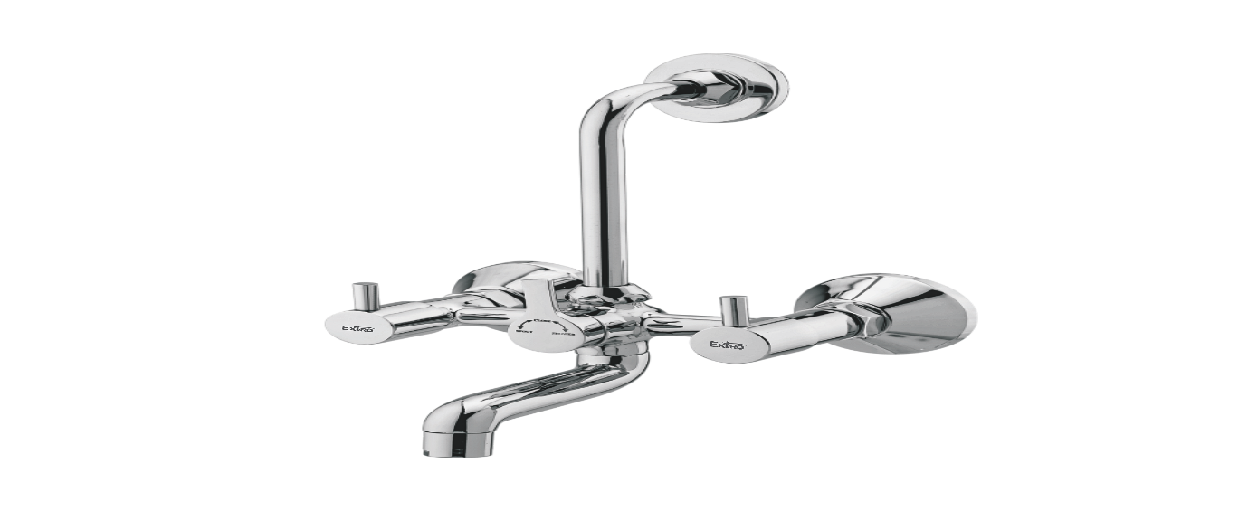

**Extro Sink Cock with Swivel Spout (Wall Mounted)**

**Product Description:**  
A modern wall-mounted sink cock with a high-rise swivel spout designed for kitchen and washbasin use, delivering style, durability, and precise water control.

**Key Features :**  
✅ High arch 360° swivel spout

✅ Wall mounted for space saving

✅ Smooth single-lever operation

✅ Chrome finish corrosion resistance

✅ Brass body for long durability

**Product Specifications:**  
• Brand: Extro  
• Type: Sink Cock with Swivel Spout  
• Installation: Wall Mounted  
• Spout Type: Swivel / Rotatable  
• Body Material: Brass  
• Finish: Chrome Plated  
• Cartridge Type: Quarter Turn Ceramic Disc  
• Inlet Connection Size: 15mm BSP  
• Handle Type: Single Lever  
• Ideal For: Kitchen Sink / Utility Basin  
• Warranty: 10 Years Manufacturer Warranty

